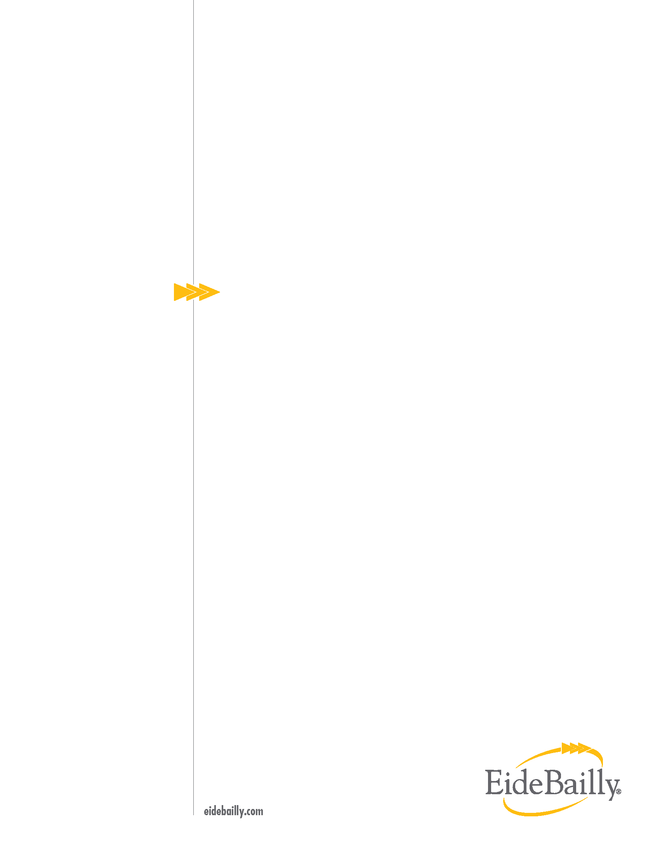
Preliminary Risk Assessment of Body Worn Camera Program

September 2022

Carson City

Sheriff DEPARTMENT

Submitted By:

Eide Bailly LLP

Audrey Donovan, CIA, CGAP, CRMA
Senior Manager, Risk Advisory Services


Table of contents
Objective & Scope 3
Methodology 3
Background and Results 3
OBSERVATION #1: Body Worn Camera Activation 4
RECOMMENDATION for Observation #1 4
OBSERVATION #2: Video Uploads & Categorization 6
RECOMMENDATION for Observation #2 6
OBSERVATION #3: Monitoring BWC Program 7
RECOMMENDATION for Observation #3 7
OBSERVATION #4: BWC Policy 8
RECOMMENDATION for Observation #4 8
Appendix A 9
Appendix B 10

Objective & Scope
The objective was to perform a preliminary risk assessment (RA) of the Body Worn Camera (BWC) program within the Sheriff’s Office to assess risk of the program and provide the Audit Committee with information to make an informed decision on whether the program should have an internal audit performed.

The Scope of the engagement is the Sheriff’s Office BWC program including the City Jail as of the assessment period, July through August 2022.

We conducted this engagement in accordance with the International Standards for the Professional Practice of Internal Auditing. Those standards require that we plan and perform the engagement to obtain sufficient and appropriate evidence to provide a reasonable basis for our findings and conclusions based on our audit objectives. We believe that the evidence obtained provides a reasonable basis for our findings and conclusions based on our objectives. Our work was limited to those areas specified in the "Objective, Scope, and Methodology" sections of this report.

Methodology
Based on the above objective, we performed the following procedures:
- Obtained and reviewed the Nevada Revised Statute (NRS) 289.830 specific to body worn camera.
- Obtained and reviewed the Sheriff’s Office policies and procedures (P&Ps).
- Compared P&Ps to NRS 289.830.
- Discussed the BWC program, related processes, and system vendor with the City’s Undersheriff, Jerome Tushbant.
- Performed best practice research on BWC programs.

Background and Results
The Sheriff’s Office implemented the requirements of NRS. 289.830 with the passing of Senate Bill 176 that stated law enforcement agencies must require their uniformed peace officers who routinely interact with the public to wear portable event recording devices by July 1, 2018. The law requires the adoption of P&Ps that include specific requirements for the use of body camera device and video retention of no less than 15 days (see Appendix A for NRS 289.830).
A body-worn camera (BWC) is a small, battery-powered camera worn by uniformed officers to record interactions with the public. The cameras are used to promote transparency and accountability through objective evidence. The policy includes procedures for: when to activate and deactivate the camera, when and where recording is prohibited, data retention, oversight, and the disclosure or release of videos.
Through our discussions with the Undersheriff, every deputy, sergeant, and investigator are equipped with a body worn camera. Deputies are required to go on duty with all equipment in good working order to include a charged and working BWC. A failure to report a non-working device, without good cause, could result in disciplinary action. Supervisors are required to conduct periodic inspections of equipment to include a visual check that the deputy has the BWC device in their possession.
Marked and unmarked emergency vehicles, with the exception of motorcycles, are installed with Axon cameras equipped with high-tech features such as the Axon “signal” technology. This technology will activate another Axon camera if it is within approximately 11 yards of an equipped vehicle with their emergency lights turned on. This allows Carson City and others’ with the technology, such as Nevada Highway Patrol to benefit from the others’ camera footage.
The audio and video data from the cameras is stored in the cloud through a third-party vendor Axon, that provides storage and data management for both body and vehicle cameras for all City uniformed officers including the 4 jailors within the City Jail. Depending on how the video is classified (misdemeanor, use of force, arrest, liability, pedestrian, etc.) determines the amount of time the data is stored. Theoretically, the data could be stored in the cloud indefinitely.
All personnel that have a body-worn camera assigned and/or personnel with responsibilities directly related to the BWC Program need to have active access to Axon’s cloud storage system, Evidence.com. It is this active access that labels the uploaded video with the owner name. To preserve audit trails for departing employees, users are deactivated rather than being deleted altogether.
Evidence.com is a web-based portal which provides users roles, responsibilities, video reviews, and other settings for BWC as well as in-car cameras. A review of the user list is typically performed when an employee is hired, terminated, or moves assignment. This review was performed during our assessment as a result of the Sheriff’s Office adding in-car cameras to Evidence.com. Overall, review tends to occur a few times a month.
Our preliminary risk assessment identified opportunities for the Sheriff’s Office to improve the City’s BWC Program. Like any evolving program, there are opportunities for the Sheriff’s Office to improve the administration of the BWC program. We would like to thank the Sheriff and Under Sheriff for their cooperation and responsiveness to our requests and questions during our assessment.

OBSERVATION #1: Body Worn Camera Activation
The BWC Policy lists multiple instances when an officer is required to activate his or her BWC when responding to a call for service. One specific instance relates to dispatched 911 calls and self-initiated activities in which a deputy would normally notify dispatch, such as when an officer pulls someone over. In these instances, the 911 dispatch CAD (computer-aided dispatch) number should be included with the associated video footage that is uploaded.
Currently, the Sheriff’s Office does not perform video matching or monitoring of dispatch calls to ensure events that should have a BWC video, do in fact have a video. This level of review would provide information about the effectiveness of the BWCs activation rate.

RECOMMENDATION for Observation #1
The Sheriff’s Office should establish a process that ensures all officers responding to 911 dispatch calls and all self-initiated activities requiring dispatch notification have a BWC video. Additionally, performance metrics and goals should be established for BWC activation.

Management Response:
With the recent installation of the Axon “Signal” product, body cameras automatically activate when emergency lights are turned on by nearly any Carson City Sheriff’s enforcement vehicles. This will dramatically reduce the number of non-activations.

Additionally, as of September 1, 2022, the Carson City Sheriff’s Office will be testing the Axon “Performance” product which further addresses this concern. The product collects data on BWC users and compares dispatch records with video records to determine the rate of compliance. Performance is a proprietary system within the Axon environment, as such no other vendor can provide the same service.

The Sheriff’s Administration has high hopes that the Performance product will efficiently provide insight into the use of BWC’s and allow for immediate feedback. Since this product would have a budgetary impact, the office and Axon would need to negotiate terms. Axon representatives have indicated if there is a good faith intent to acquire this product a long-term trial period would be supported, pending a budgetary decision.

At this time, setting metrics and goals are problematic as the complete system; BWC, in-car cameras, along with the Signal system, has only recently been combined and is now online. It will take time to create a baseline and configure Performance to work with data from our existing systems. It is our intention to create an internal working group to divide labor and determine achievable goals.

Please note, Performance will be labor intensive to include setup and maintenance. Maintenance would include making multiple changes with the “command hierarchy” for all personnel moves as well as creating reports, monitoring the data, and investigating deficiencies/anomalies. This is beyond the requirement of line level supervisors who is tasked with randomly reviewing officers BWC video (required in the Early Alert System). With the unfunded legislative requirements, administration of the BWC program may need to fall to a dedicated specialized employee.

We believe, if Performance is funded, we will be able to provide meaningful information and address Recommendation #1 by July 1, 2023.

OBSERVATION #2: Video Uploads & Categorization
Currently, the BWC policy does not specify when a BWC device should be uploaded or categorized. Regular and timely video uploads enhance accountability and transparency as well as ensuring the availability of videos of evidentiary significance. Best practice identification and preservation of video requires BWCs to be docked at the conclusion of each shift to allow automatic uploads of any data collected to Axon’s cloud storage system, Evidence.com. Prompt docking ensures BWC files are backed up and secured within Evidence.com.
To assist with identifying and preserving data recordings, video is to be properly categorized by the officers. The retention time of each video is based on these categories. Per policy, officers should categorize their BWC recordings. This can be completed after docking the BWC device or during the officer’s shift via the Axon View app. The officer is responsible for ensuring the information is accurate and complete.

RECOMMENDATION for Observation #2
The Sheriff’s Office should update their BWC policy to address when the video upload and categorization is to occur. Additionally, the Sheriff’s Office should perform routine monitoring of the uploads and the categorization of videos for completeness and accuracy. Lastly, performance metrics and goals should be established for BWC uploads and categorization of videos. This may be accomplished through the use of Axon Performance dashboard.
Axon Performance dashboard provides key performance metrics on;
- activation rate - Compares the number of videos taken to the CAD calls the officer has responded to (see Observation #1).
- power cycle - Calculates the total time the BWC is powered on while disconnected from a docking station and is used to identify officers that fall below the agency set percentage.
- categorization rate - Compares the number of videos the officer has categorized to the total number of videos taken.
- identification rate - Compares the number of videos with an officer added or confirmed ID to the total number of officer videos.

Management Response:
The Carson City Sheriff’s Office will incorporate into policy instructions when to upload and categorize video from a BWC. This task will be complete in the next 30 days.

Monitoring of the uploads and categorization of videos can be done through the Axon “Performance” product. See Response #1 for details.

In terms of the four-performance metrics, see Response #1 for details.

OBSERVATION #3: Monitoring BWC Program
The Sheriff’s Office is finalizing the BWCs Early Warning Policy to comply with NRS 289.823 that requires law enforcement agency to establish a system to identify peace officers who display bias indicators or other problematic behavior (see Appendix B). Management oversight is a key component for a strong internal control structure. However, management oversight of BWC policy is not performed to track for trends or patterns, which would also provide additional opportunities to improve training and identify departmental weaknesses. Monitoring for compliance with the BWC program helps managers to achieve desired results through effective oversight.
Monitoring for compliance with the BWC program is currently not performed due to the limitations of the Axon services, which would require another trial period, set for December 2022, to assess cost and functionality for true random video sampling for review. This will allow supervisors and shift supervisors the ability to review based on set criteria, such as traffic stops, randomly identify the video to review, notate the video reviewed and outcomes, and maintain an audit trail of who reviewed and when.

RECOMMENDATION for Observation #3
The Sheriff’s Office should continue to roll out the BWC program’s Early Warning Policy to comply with NRS 289.823. Furthermore, the policy should implement a system and methodology to monitor the BWC video for compliance with the BWC program and policy, and identification of opportunities for improvement to include all uniformed personnel with BWC devices, including the Jailors. This should include an evaluation of the total reviews that need to be completed in order to be statistically significant in comparison to the total of BWC footage of each uniformed personnel with a BWC device or other means of how supervisors chose videos for review, such as utilizing the feature within the Axon software that aids in the random selection of the videos for review. Lastly, the supervisor’s monitoring of the videos should also be reviewed for compliance with set methodology and intent of the program and related policies.

Management Response:
The Sheriff’s Office has established policy to address the Early Warning Policy, as per NRS 289.823. The implementation of Performance will take up the recommendations above.

In terms of jailors, they are not required to have BWC; however, they have been issued provide additional audio/visual documentation and record of events. The internal workgroup mentioned above will address and publish policy for camera use within the jail.

These recommendations can be addressed specific to the patrol/investigations divisions through data supplied by the Performance product. See Response #1.

OBSERVATION #4: BWC Policy
As part of our assessment we reviewed the procedures outlined in the BWC policy and compared them to the requirements in the NRS 289.830 and noted for section 1.f., that disciplinary rules for peace officers have not been established in policy. The state statute, section 1.f., requires that disciplinary rules for peace officers be established for failure to operate a BWC device in accordance with policy, intentional manipulation of a video recorded to a BWC device, or prematurely erasing a video recorded by a BWC device. Having a policy for disciplining these actions creates an understanding and expectation for officers if this were to happen.

RECOMMENDATION for Observation #4
Review and update the current BWC policy to reflect current operating practices and alignment with NRS 289.830. Specifically, the policy should be updated to include disciplinary actions.

Management Response:
BWC policy is currently in review as a natural course of implementing the in-car camera as well as the early warning polices.

Although not specifically mentioned in the BWC policy, it is a violation of Standards of Conduct for an employee’s, “Failure to operate a portable recording device as required by the Office and/or editing or erasing any portion of a recording”. See policy 339.5.8.(J). Discipline for the violation can range from a warning up to and including termination.

Appendix A

NRS 289.830
Certain law enforcement agencies shall require certain peace officers to wear portable event recording device while on duty; adoption of policies and procedures governing use; request for and inspection of record made by device.

1. A law enforcement agency shall require uniformed peace officers that it employs and who routinely interact with the public to wear a portable event recording device while on duty. Each law enforcement agency shall adopt policies and procedures governing the use of portable event recording devices, which must include, without limitation:
(a) Except as otherwise provided in paragraph (d), requiring activation of a portable event recording device whenever a peace officer is responding to a call for service or at the initiation of any other law enforcement or investigative encounter between a uniformed peace officer and a member of the public;
(b) Except as otherwise provided in paragraph (d), prohibiting deactivation of a portable event recording device until the conclusion of a law enforcement or investigative encounter;
(c) Prohibiting the recording of general activity;
(d) Protecting the privacy of persons:
(1) In a private residence;
(2) Seeking to report a crime or provide information regarding a crime or ongoing investigation anonymously; or
(3) Claiming to be a victim of a crime;
(e) Requiring that any video recorded by a portable event recording device must be retained by the law enforcement agency for not less than 15 days; and
(f) Establishing disciplinary rules for peace officers who:
(1) Fail to operate a portable event recording device in accordance with any departmental policies;
(2) Intentionally manipulate a video recorded by a portable event recording device; or
(3) Prematurely erase a video recorded by a portable event recording device.
2. Any record made by a portable event recording device pursuant to this section is a public record which may be:
(a) Requested only on a per incident basis; and
(b) Available for inspection only at the location where the record is held if the record contains confidential information that may not otherwise be redacted.
3. As used in this section:
(a) “Law enforcement agency” means:
(1) The sheriff’s office of a county;
(2) A metropolitan police department;
(3) A police department of an incorporated city;
(4) A department, division or municipal court of a city or town that employs marshals;
(5) The Nevada Highway Patrol; or
(6) A board of trustees of any county school district that employs or appoints school police officers.
(b) “Portable event recording device” means a device issued to a peace officer by a law enforcement agency to be worn on his or her body and which records both audio and visual events occurring during an encounter with a member of the public while performing his or her duties as a peace officer.

Appendix B

NRS 289.823 (“Early Warning Policy”)
Requirement for law enforcement agency to establish early warning system to identify peace officers who display bias indicators or other problematic behavior; duties of law enforcement agency upon such identification.

1. Each law enforcement agency shall establish an early warning system for the purpose of identifying peace officers employed by the law enforcement agency who:
(a) Display bias indicators by, for example:
(1) Having a large number of citizen complaints;
(2) Being part of a large number of incidents involving the use of force;
(3) Making a large number of arrests for resisting an officer;
(4) Having a large number of the arrests that he or she has made result in no charges being filed because of issues such as improper searches or detentions; or
(5) Having a negative attitude regarding programs that enhance relations between law enforcement and the community.
(b) Display other problematic behavior by, for example:
(1) Having a large number of motor vehicle crashes;
(2) Abusing sick leave; or
(3) Showing any other behavioral signs that are indicative of a decline in performance.
2. If a peace officer is identified by the early warning system as displaying bias indicators or other problematic behavior, the law enforcement agency that employs the peace officer shall:
(a) Increase its supervision of the peace officer; and
(b) Provide additional training and, if appropriate, counseling to the peace officer.
3. If a peace officer is repeatedly identified by the early warning system as displaying bias indicators or other problematic behavior, the law enforcement agency that employs the peace officer shall consider the consequences that should be imposed, including, without limitation, whether the peace officer should be transferred from any high-profile assignments or subject to any discipline.



Carson City body cameras were rolled out in mid-June, 2018, 2 weeks ahead of schedule.
Camera footage within the jail, except BWC, is maintained by the City’s IT Department. The data storage is a current on-going project and at the time of our assessment this project was at 90% complete. Currently, the City has been storing this and other data forever due to lack of data retention policy, which the District Attorney’s office is currently working on finalizing.
The Portable Audit/Video Recorders Policy.
Best Practice performance metric compares the number of videos taken to the Computer-Aided Dispatched calls the officer has responded to. Best Practice BWC goal is >80% activation rate.

