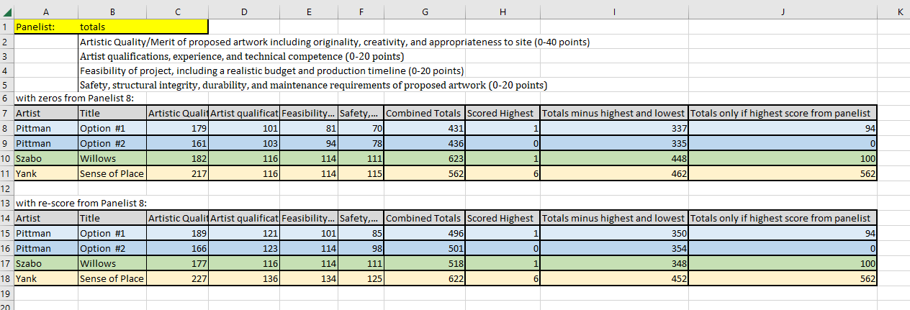

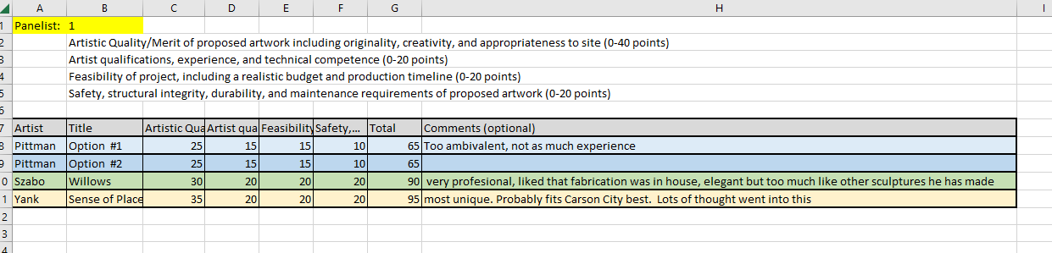
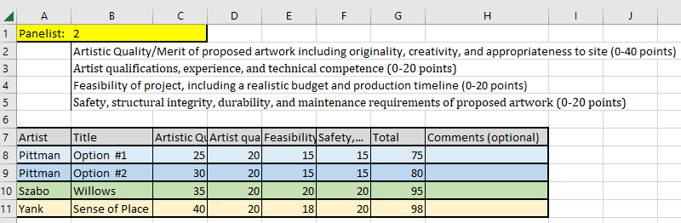

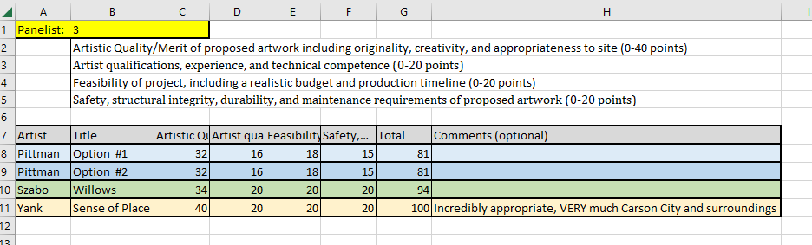
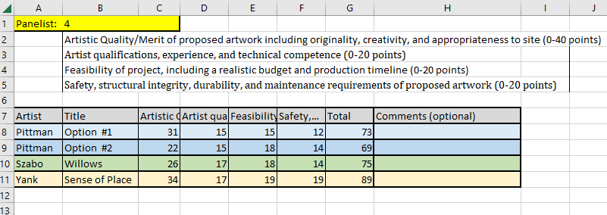

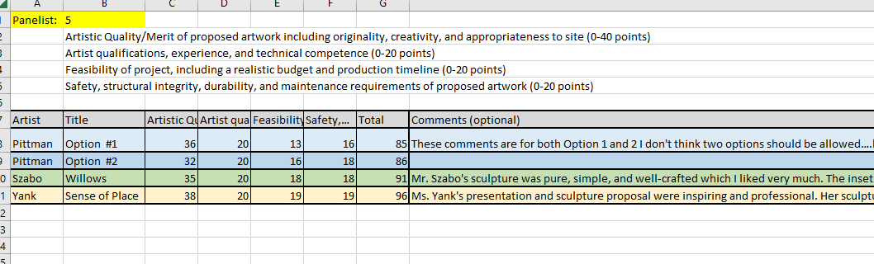

These comments are for both Option 1 and 2 I don't think two options should be allowed….but, be that as it may. Mr. Pittman's presentation material was highly professional, well assembled, and detailed. I was concerned that he described different evolutions of the sculptures based on how the budget would evolve. Such as, being able to use color lighting in option 1 if the budget depleted. Same with option 2, the scale of the sculpture might be smaller if he were to use some of the budget for lighting. To me, that information should have been worked out ahead time and I would be concerned about what/how the sculpture would evolve during the process.

Mr. Szabo's sculpture was pure, simple, and well-crafted which I liked very much. The inset lighting was an elegant touch that really set his sculpture apart from the others. I liked the explanation of the willow theme, but I thought the concept was a little too abstract. Meaning, all the Carson area motifs and symbols were layered upon the 3 willow leaves, which is asking a lot of the viewer.

Ms. Yank's presentation and sculpture proposal were inspiring and professional. Her sculpture resonated as the most gateway piece of all the proposals and her composition of the motifs within it were outstanding. To be able to achieve such a variety of scale, texture, and imagery with a similar material (steel) is quite the accomplishment. Her proposal was my favorite.

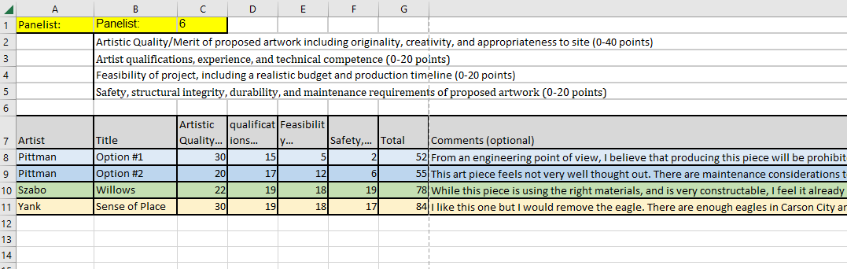

From an engineering point of view, I believe that producing this piece will be prohibitively expensive. l have done similar size towers and the material selected is nowhere near adequate. I would suspect that after engineering was complete, this piece would look significantly different from what was presented.

This art piece feels not very well thought out. There are maintenance considerations to be made. Use of color coated material has a very short lifespan in public art, I don't see it holding up past 15, 20 years.

While this piece is using the right materials, and is very constructable, I feel it already looks dated. I feel like half the public artwork in this country over the last 15 years looks similar to this.

I like this one but I would remove the eagle. There are enough eagles in Carson City and the complete circle I believe would look better. I can already see beautiful sunsets photographed with this piece silhouetted in the foreground, having the complete circle without the eagle will look much better. I also would not allow any tribal symbolism without giving that portion over entirely to the local tribal leaders. I liked the various depths to the tree. I'd be curious to see a rendering with one or two more layers building up that tree section.

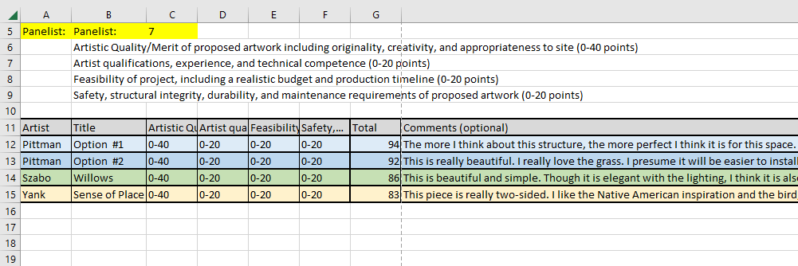

The more I think about this structure, the more perfect I think it is for this space. I really love the mining inspiration, and how it looks like a light bulb. It still intrigues me, even after thinking about it for days.
This is really beautiful. I really love the grass. I presume it will be easier to install than the mining one.
This is beautiful and simple. Though it is elegant with the lighting, I think it is also forgettable.
This piece is really two-sided. I like the Native American inspiration and the bird, but it doesn’t stand out to me, nor connect with anything meaningful within the corridor. It would go great with the i-580 cultural motif.

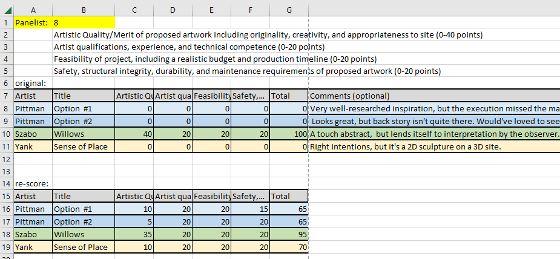

Very well-researched inspiration, but the execution missed the mark.
Looks great, but back story isn't quite there. Would've loved to see a combination of both options.
A touch abstract, but lends itself to interpretation by the observer. I see flames in it, and I especially like that it will be in motion while you're driving around it.
Right intentions, but it's a 2D sculpture on a 3D site.

