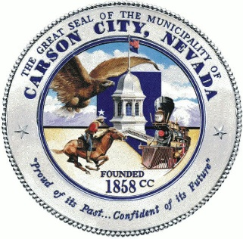
Application Review Workgroup (ARWG)
Volunteer Application
Date: Click or tap here to enter text. Phone: Click or tap here to enter text.
Name: Click or tap here to enter text. Email: Click or tap here to enter text.
Address:Click or tap here to enter text.

Grant Review Experience
Provide specific information about your grant review history.
☐Experienced Carson City grant reviewer
☐No Carson City grant reviewer experience
☐Experienced federal grant reviewer
☐Experienced non-federal grant reviewer
☐No grant reviewer experience

Please describe your experience reviewing grant applications.

Do you have professional or volunteer experience in any of the following?
☐Grants management ☐Substance abuse services ☐Health services
☐Non-profit ☐Domestic abuse services ☐Dental services
☐Local government ☐Senior services ☐Youth services
☐Public works ☐Disabled services
☐Community development ☐Mental health services

Please briefly describe your experience in these categories.

Are you affiliated with any nonprofit organizations in Carson City? ☐ Yes ☐No
If yes, please list any and what your affiliation is.

Briefly share why you are interested in joining the Application Review Workgroup.

By submitting this application, I affirm that the facts set forth in it are true and complete. I understand that if I am accepted as a volunteer, any fall statements, omissions, or other misrepresentations made by my on this application may result in my immediate dismissal.

Name (printed)______________________________________________________

Signature__________________________________________________________Date___________

It is the policy of this organization to provide equal opportunities without regard to race, color, religion, national origin, gender, sexual preference, age, or disability.

Under the Privacy Act of 1974 any personally identifiable information obtained through this application will be kept private to the extent of the law.

