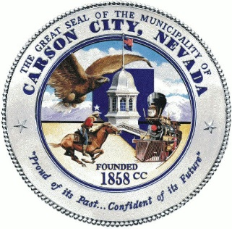
Application Review Workgroup (ARWG)
Volunteer Application

Date: Click or tap here to enter text. Phone: Click or tap here to enter text.
Name: Click or tap here to enter text. Email: Click or tap here to enter text.
Address:Click or tap here to enter text.

Grant Review Experience
Provide specific information about your grant review history.
☐Experienced Carson City grant reviewer
☐Experienced federal grant reviewer
☐Experienced grant reviewer - other
☐No grant review experience

Please describe your experience with grants.

Do you have professional or volunteer experience in any of the following?
☐Grants management ☐Performing Arts
☐Non-profits ☐Visual Arts
☐Local government ☐Community development

Please briefly describe your experience in these categories.

Are you affiliated with any nonprofit organizations in Carson City? ☐ Yes ☐No
If yes, please list organization(s) and what your affiliation is.

By submitting this application, I affirm that the facts set forth in it are true and complete. I understand that if I am accepted as a volunteer, any false statements, omissions, or other misrepresentations made by me on this application may result in my immediate dismissal.

Name (printed)______________________________________________________

Signature__________________________________________________________Date___________

It is the policy of this organization to provide equal opportunities without regard to race, color, religion, national origin, gender, sexual preference, age, or disability.

Under the Privacy Act of 1974 any personally identifiable information obtained through this application will be kept private to the extent of the law.

