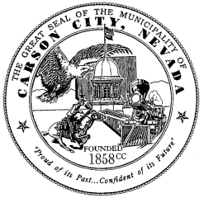
LETTER OF INTENT TO APPLY
2025-2026 Community Support Services Grant (CSSG) Program
Due October 06, 2025, by 4:00 p.m.

Purpose Statement:
NEW RENEWAL
Name of Organization:
Address:
Contact Person:
Telephone:
Email:
Requested amount:
Your Project or program needs to meet one of the critical needs listed below and serve the residents of Carson City. Please check only one box.
Dental Services
Unhoused Identification Services
Transportation Services
Prenatal Services
Project Description:

Submit completed forms to the Grants Administrator at grants@carson.org no later than 4:00 p.m. on October 6, 2025. Notifications regarding eligibility to apply will be issued on October 9, 2025. All determinations of approval or disapproval are made solely at the discretion of Carson City Management.

