FY2027
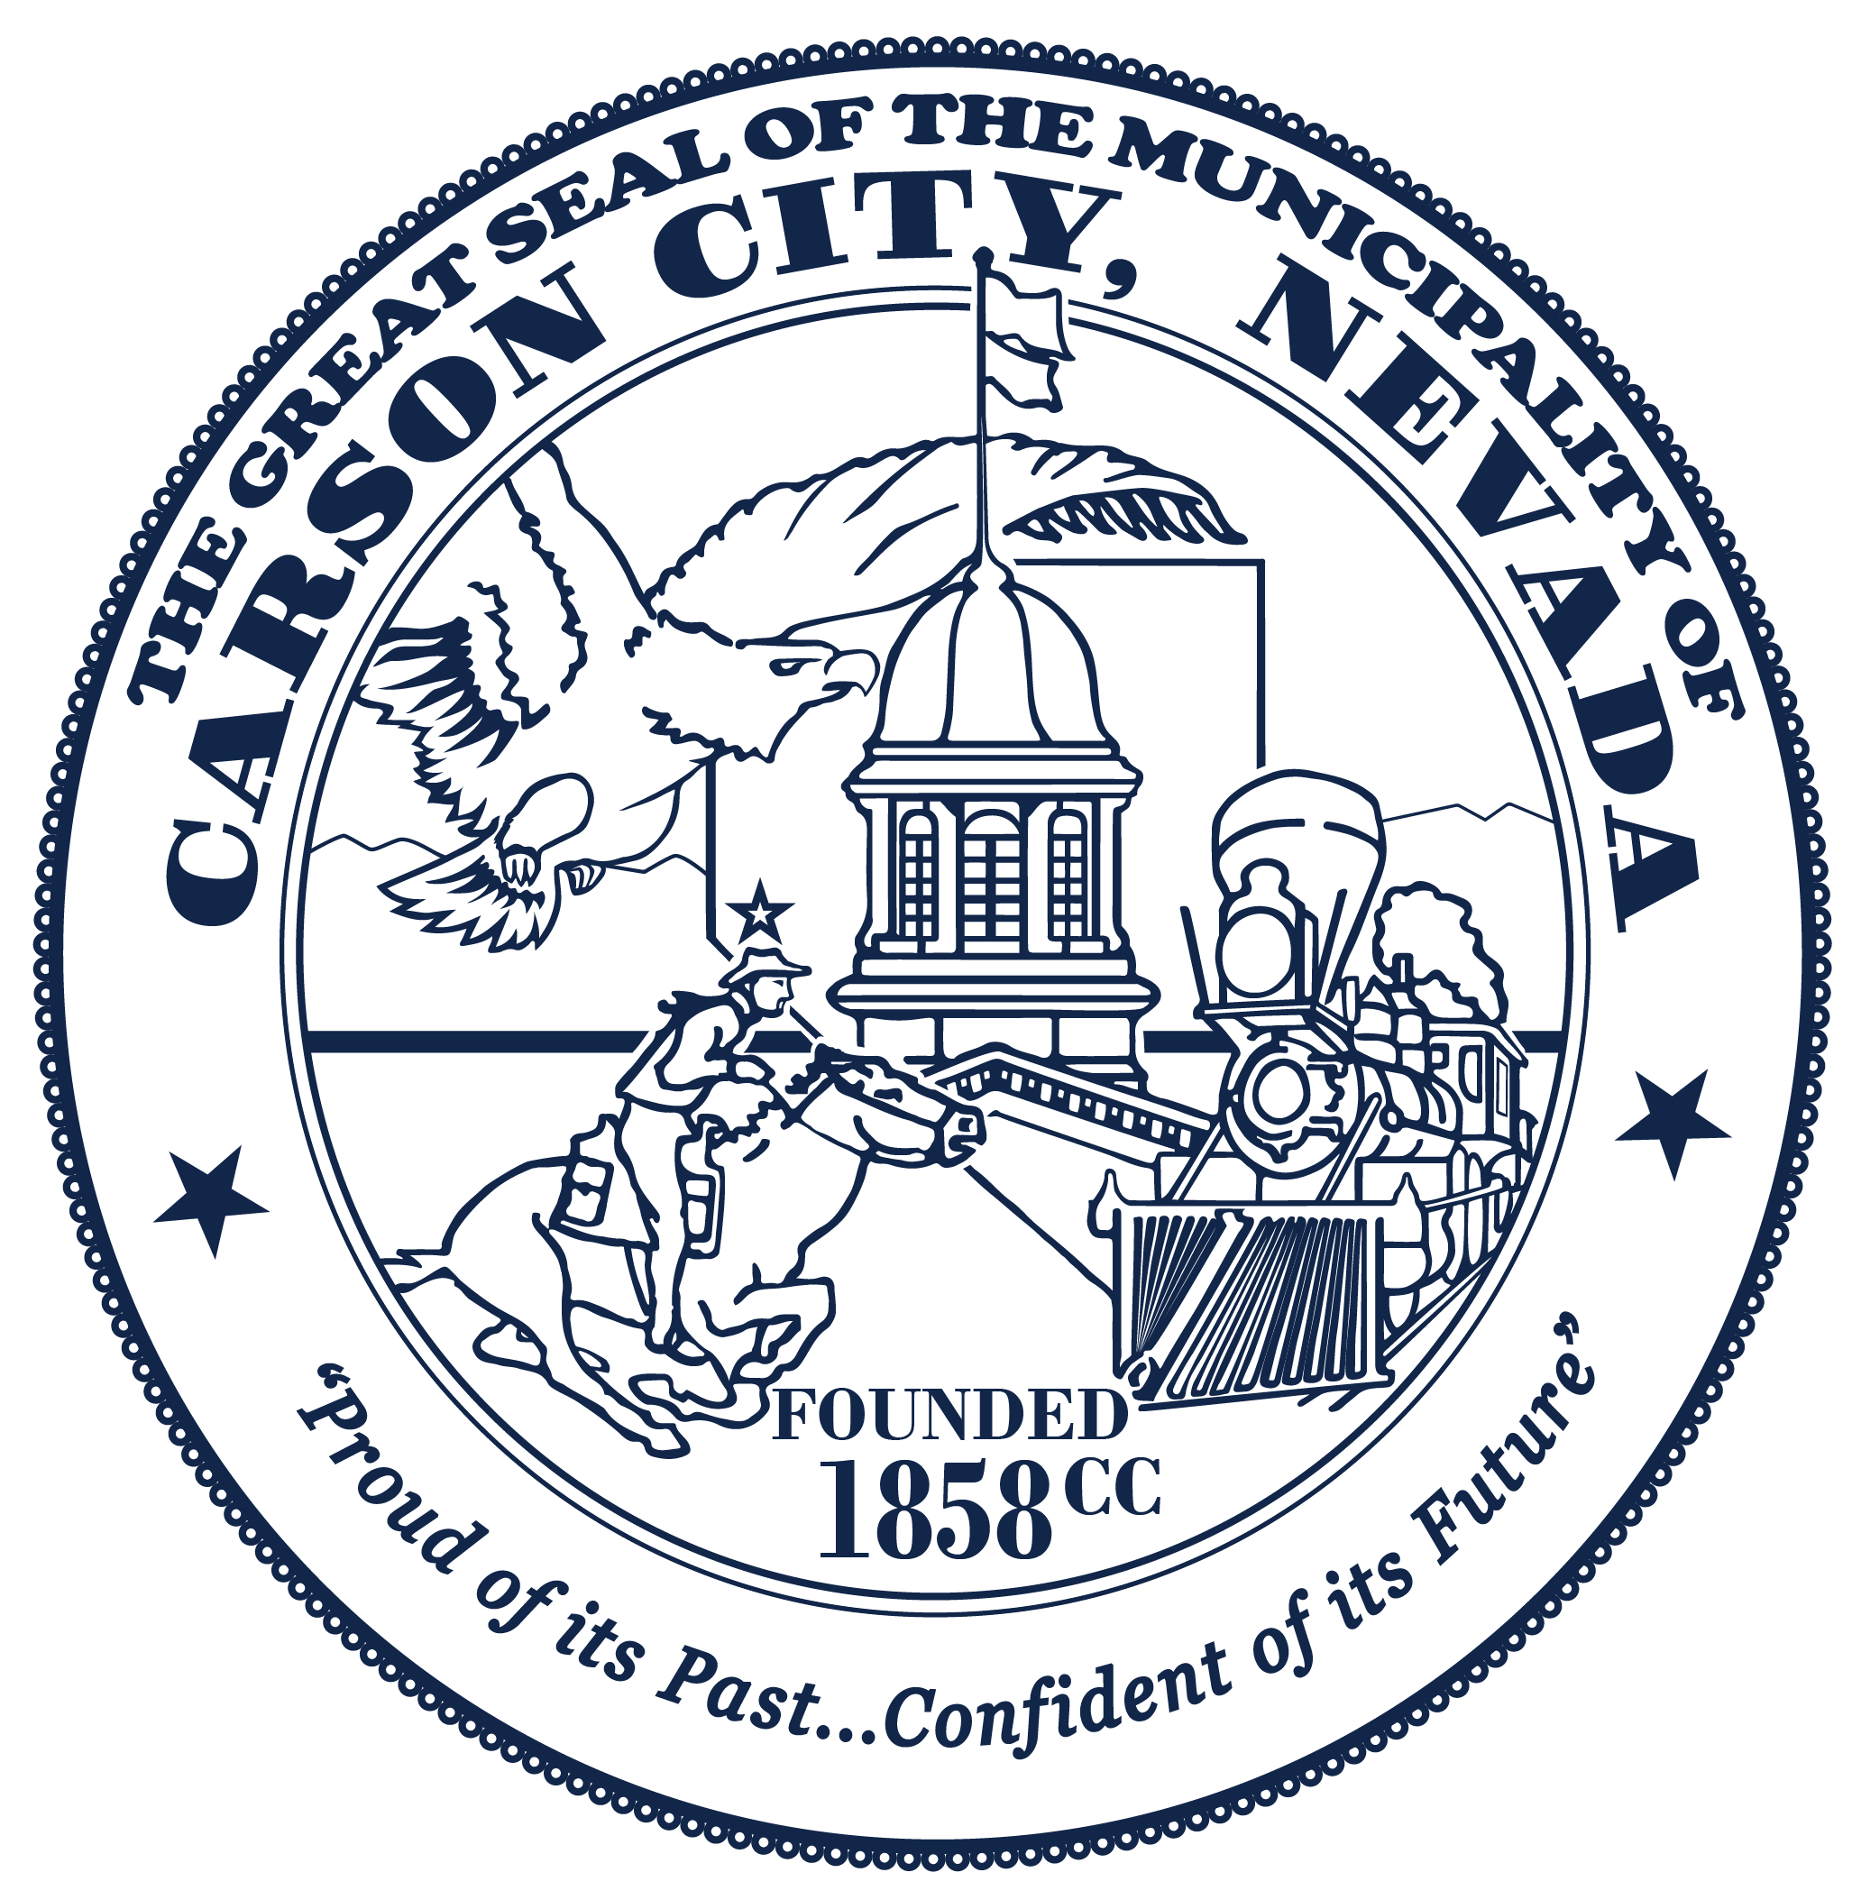

FY2027 Community Support Services Grant Letter of Intent to Apply

Submission Instructions

Letter of Intent to Apply (LOI) Due Date:
April 27, 2026, by 4:00 p.m. (PST)
Please submit completed Letters of Intent to:
Email: grants@carsoncity.gov

Whom can I contact if I have additional questions?
Yesenia Pacheco, MBA
Grants Administrator
Email: grants@carsoncity.gov
Phone Number: (775) 283-7069

Additional Information
- Submission of a Letter of Intent does not guarantee an invitation to submit a full application or receipt of funding.
- Letters of Intent will be evaluated for alignment with Board-established priorities.
- Selected applicants will be invited to submit a full application.
- All funding decisions are made at the sole discretion of the Carson City Board of Supervisors.
- Notification of eligibility will be issued on April 30, 2026.

Late submissions will not be accepted

LETTER OF INTENT TO APPLY

Applicant Information
Application Type:
☐ New Application ☐ Renewal Application
City Department/ Organization Name:
Physical Address:
Primary Contact Name & Title:
Telephone:
Email:
Total Requested Amount: $___________
Program Eligibility & Priority Area
In accordance with the Board of Supervisors’ direction, funding will be prioritized in the following order:
1. Statutorily mandated services
2. City-supported, system-critical programs
3. Dental services
4. Other qualifying programs, as funding permits

All proposed programs must:
- Serve residents of Carson City
- Operate within Carson City boundaries
- Align with one (1) of the priority areas below
Select one priority area:
☐ Court Appointed Special Advocates (Juveniles)
☐Domestic Violence Advocacy
☐ Child Advocacy / Forensic Interview Services
☐Preventive Child and Family Support Services
☐ Mental and Behavioral Health Services
☐Transportation Services (To improve access to healthcare and food)
☐Dental Services

Project Title:

Purpose Statement (2–3 sentences). Provide a clear and concise statement describing the purpose of the proposed program and the need it addresses.

Project Description (Maximum: 300 words)
Briefly describe:
• The population to be served
• Key services or activities
• How the program addresses the identified need
• Anticipated outcomes or impact

